**1. Installing Windows 11 Operating System documentation**

I downloaded the latest operating system which is Windows 11

[@https://www.microsoft.com/software-download/windows11](https://www.microsoft.com/software-download/windows11)

But I could not run it because I already had it, so I went to the next step.

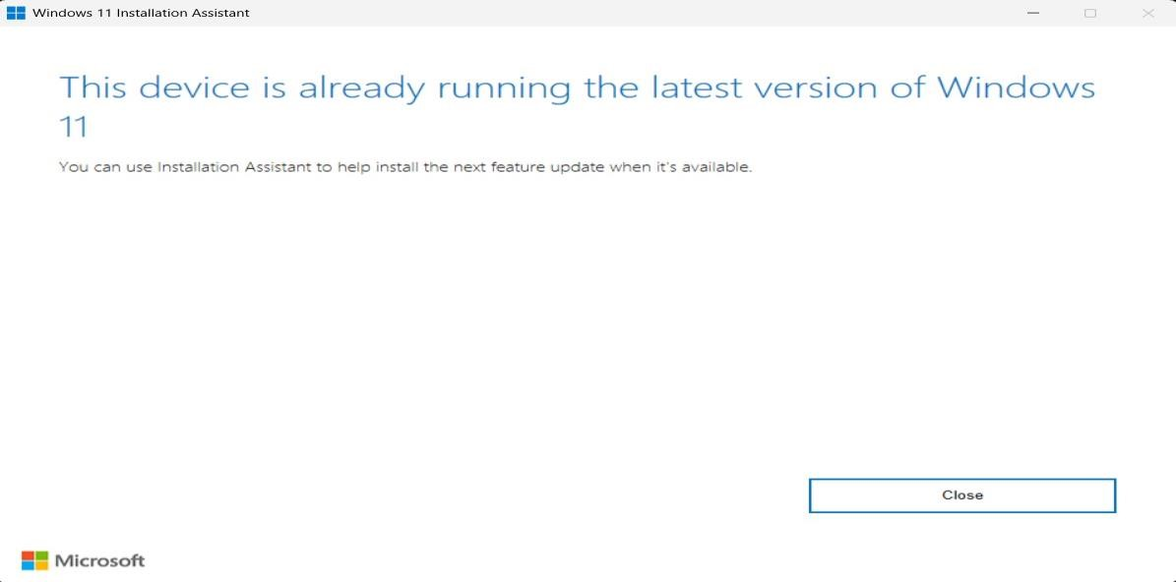

# 2. Installation of Visual Studio Code

I downloaded the latest version of Visual Studio, which is version 1.90 [@https://code.visualstudio.com/Download](https://code.visualstudio.com/Download)

## I run it administrator

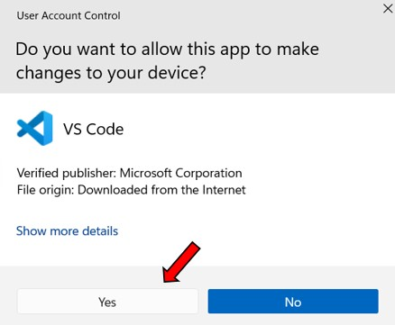

## I clicked ok

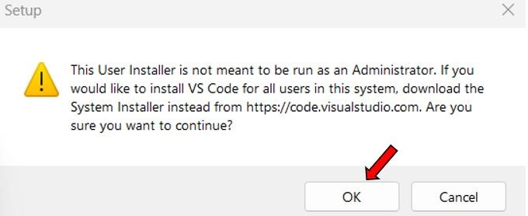

## I accepted the agreement

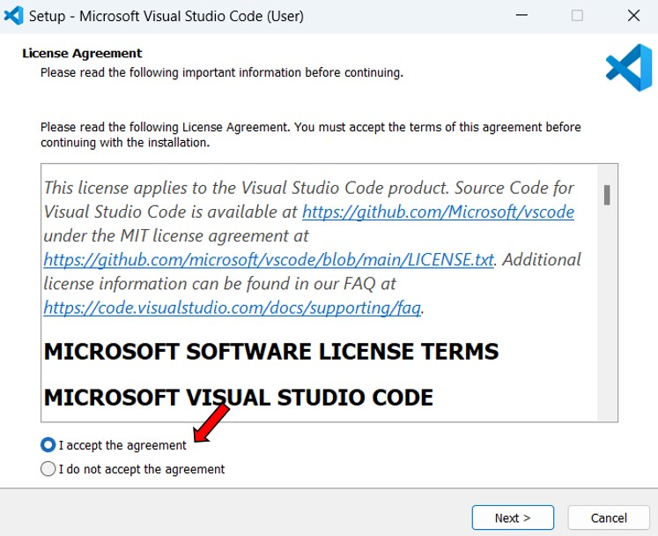

## I kept the destination location at default

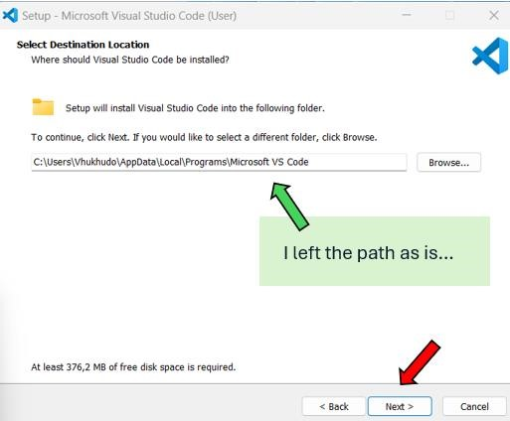

## I left the folder name as is

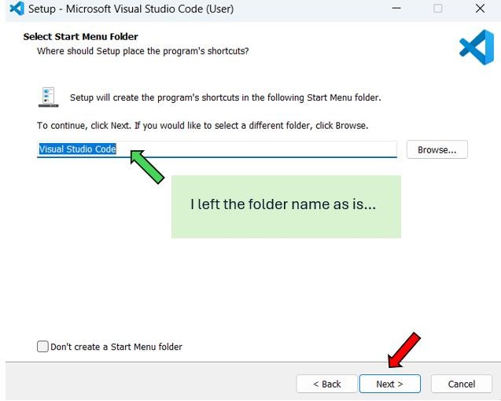

## I customized the settings

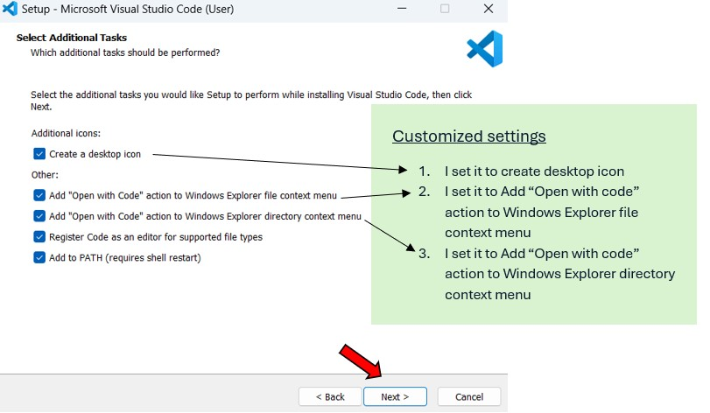

## I installed

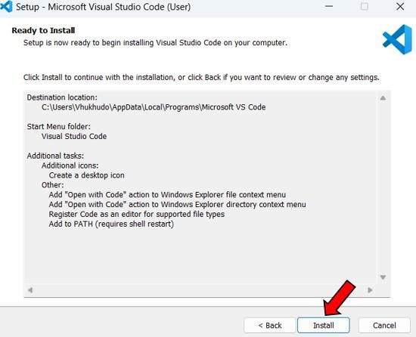

**Conclusion**

My Visual Studio Code app was successfully installed



**3. Setting Up Version Control System**

## I downloaded the latest version of git, which is version 2.45.2

[**@**https://www.git-scm.com/downloads](https://www.git-scm.com/downloads)



## I run it as administrator

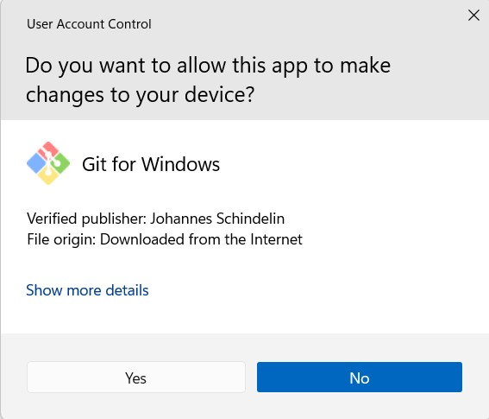

## I clicked on next

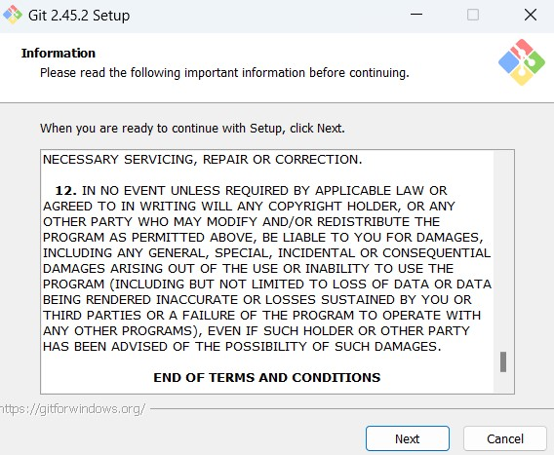

## I kept the destination location at default

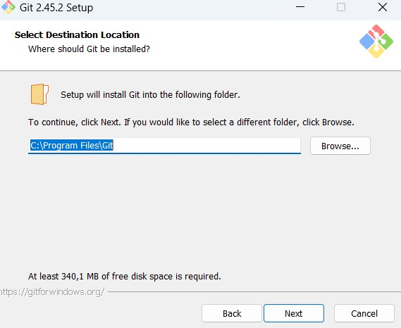

I left the path as is…

## I customized the settings

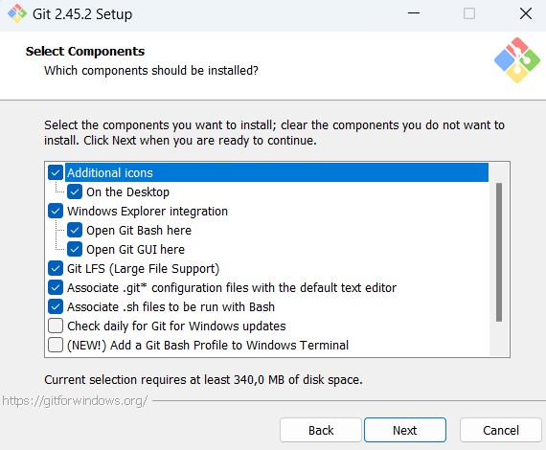

Customized settings

1.

I set it to create a

desktop icon

## I left the folder name as is

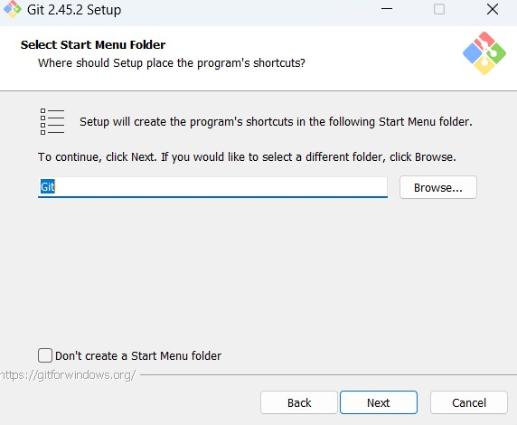

I left the folder name as is…

## I selected the default editor (Vim) used by Git

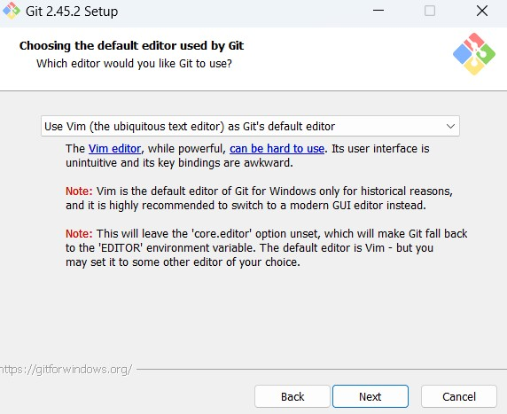

## I selected to override the default branch name (master) to main

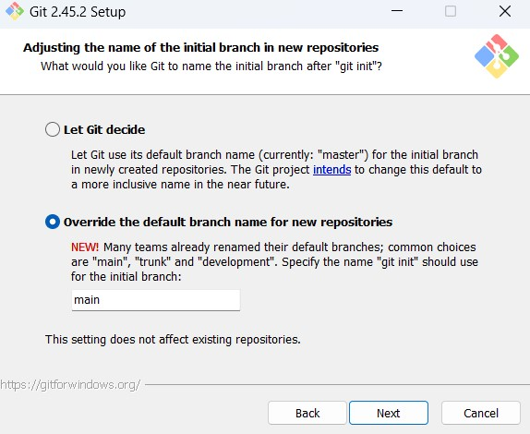

## I set using Git from the command line at default

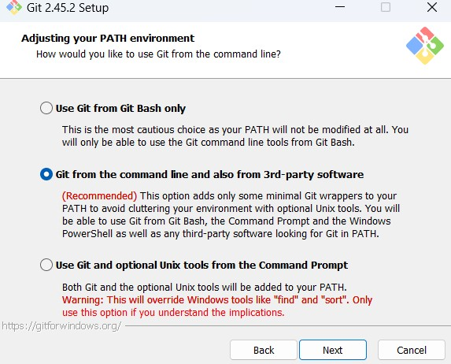

## I set the SSH executable at default

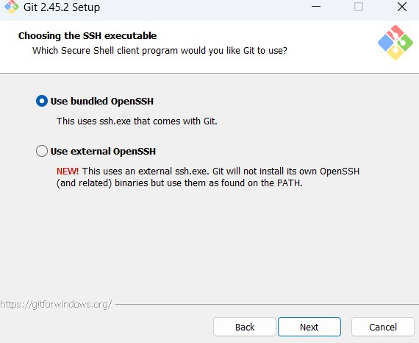

## I set the HTTPS transport backend tht will be used by Git at default

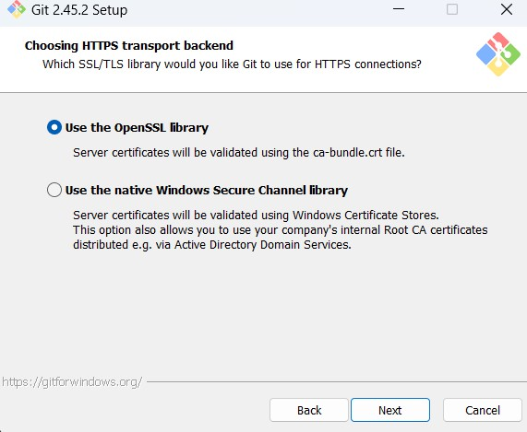

## I set the line ending conversions configuration at default

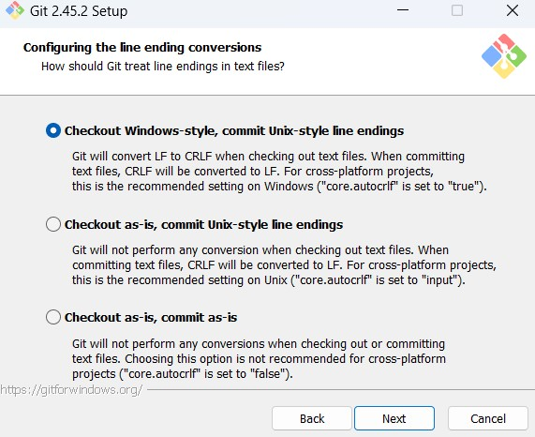

## I set the terminal emulator configuration at default

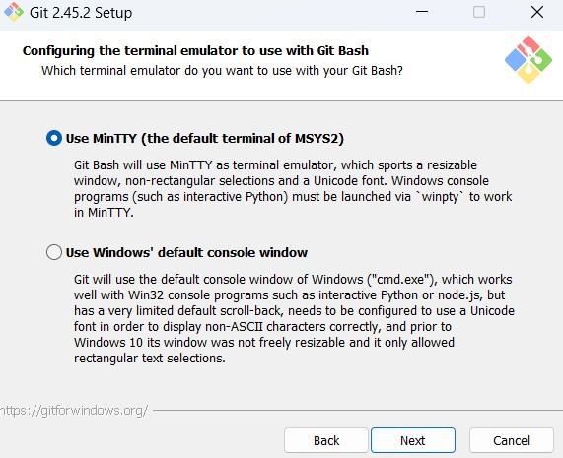

## I set the behaviour of git pull at default

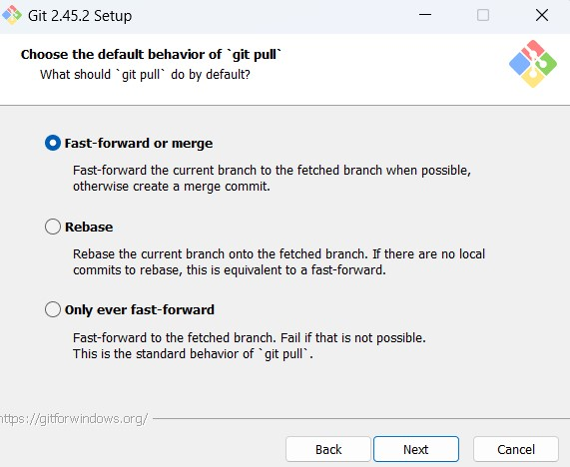

## I chose a credential helper

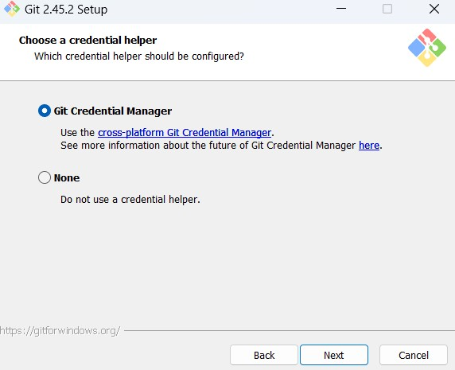

**I configured extra options**

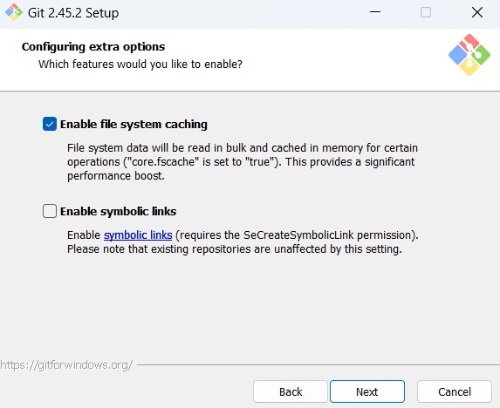

**I left the experimental options configurations as is**

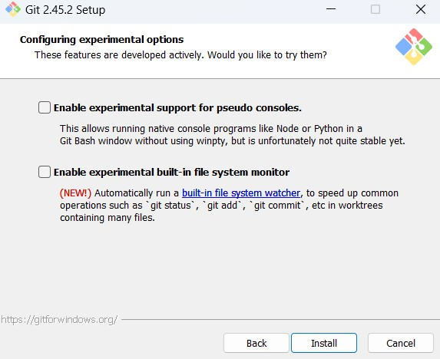

I then installed…

## Conclusion

My git app was successfully installed



# Configuring Git with GitHub

## Git configuration

I configured git using my username and email address

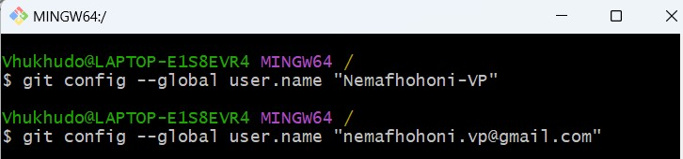

## GitHub Account

I created a GitHub account [@https://github.com/Nemafhohoni-VP](https://github.com/Nemafhohoni-VP)

**Created a new repository** on GitHub using the assignment link

**Got the Repository URL** [https://github.com/Nemafhohoni-VP/se-assignment-1-setting-upyour-developer-environment-Nemafhohoni-VP.git](https://github.com/Nemafhohoni-VP/se-assignment-1-setting-up-your-developer-environment-Nemafhohoni-VP.git)

**Forked the assignment**

**Cloned it**

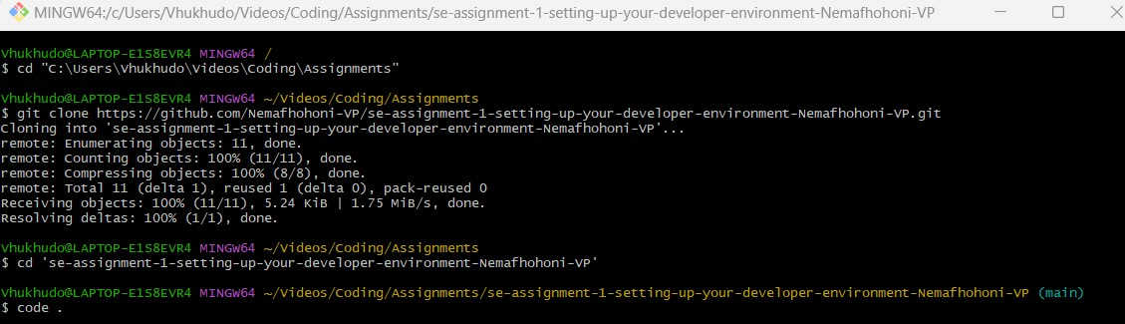

**Did the assignment**

**Initialized git**

**Tracked my folder**

**Git commit**

**Git push**

# 4. Installation of Python

I downloaded the latest version of python, which is version 3.12.4

@ <https://www.python.org/downloads/>

## I run it as administrator

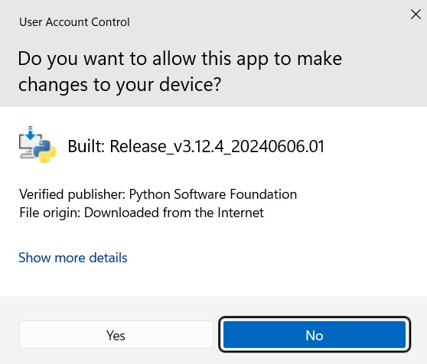

## I selected add python.exe to PATH and the install now option

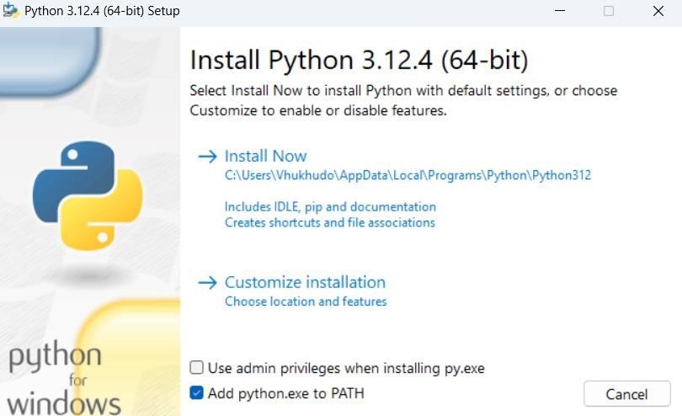

## Conclusion

My python app was successfully installed

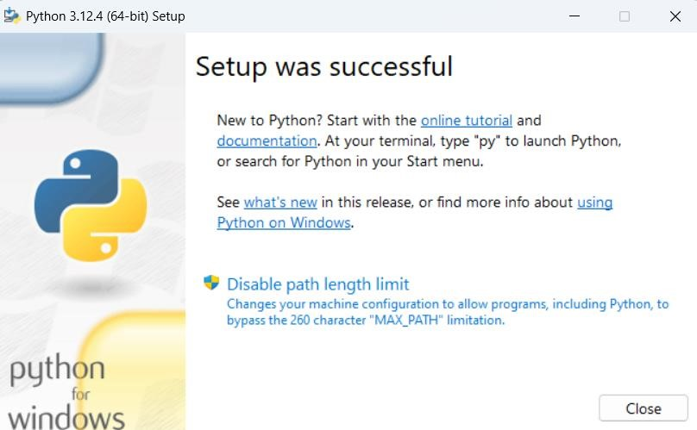

**5. Compilers, and interpreters and runtimes**

Installed pip

-

24

.0

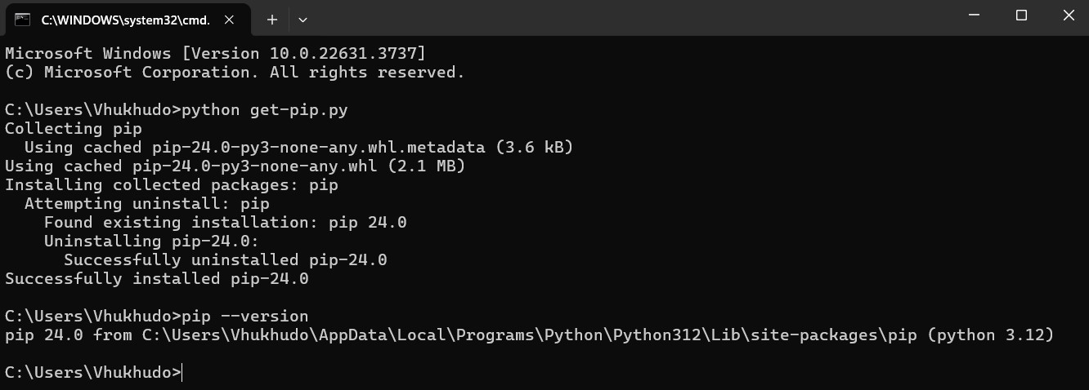

Installed python interpreter

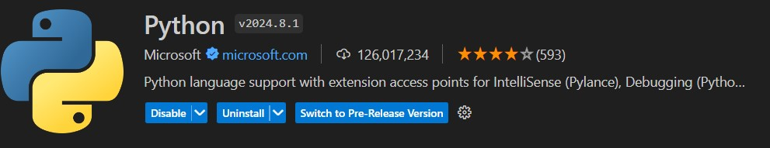

Installed Code Runner



Installed Prettier

–

code formatter



**6. Installation of MySQL**

I downloaded MySQL, version 5.7.44.0

@<https://dev.mysql.com/downloads/windows/installer/5.7.html>

**I allowed the app to make changes to my device**

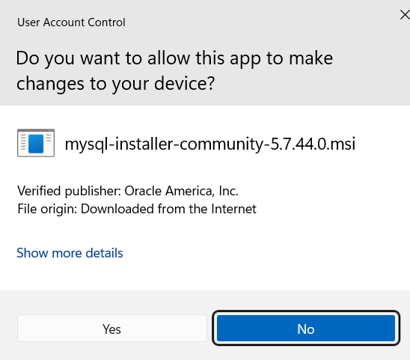

**I allowed the app to make changes to my device**

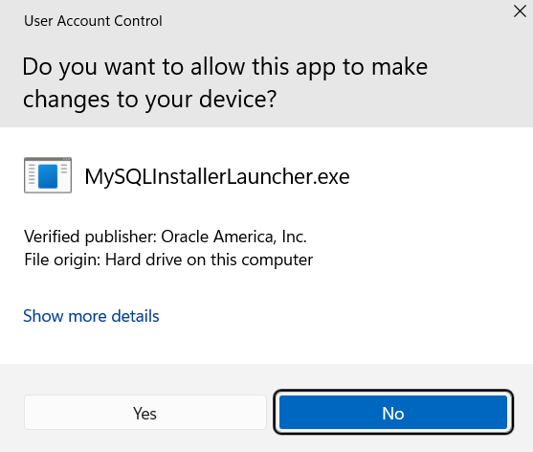

**I selected the server only setup**

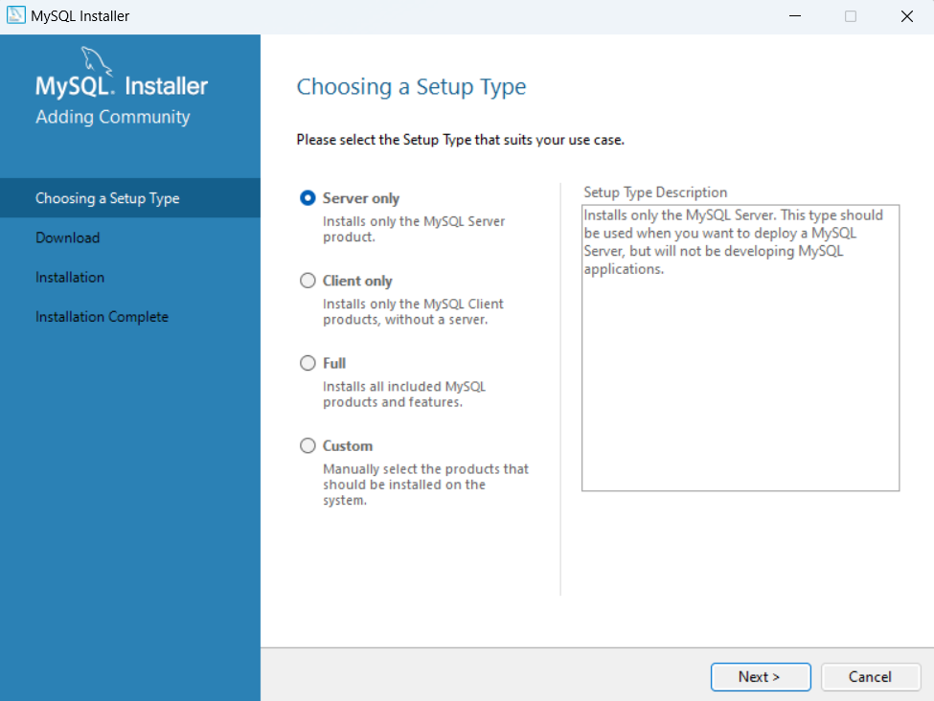

**I installed the MySQL Server 5.7.44**

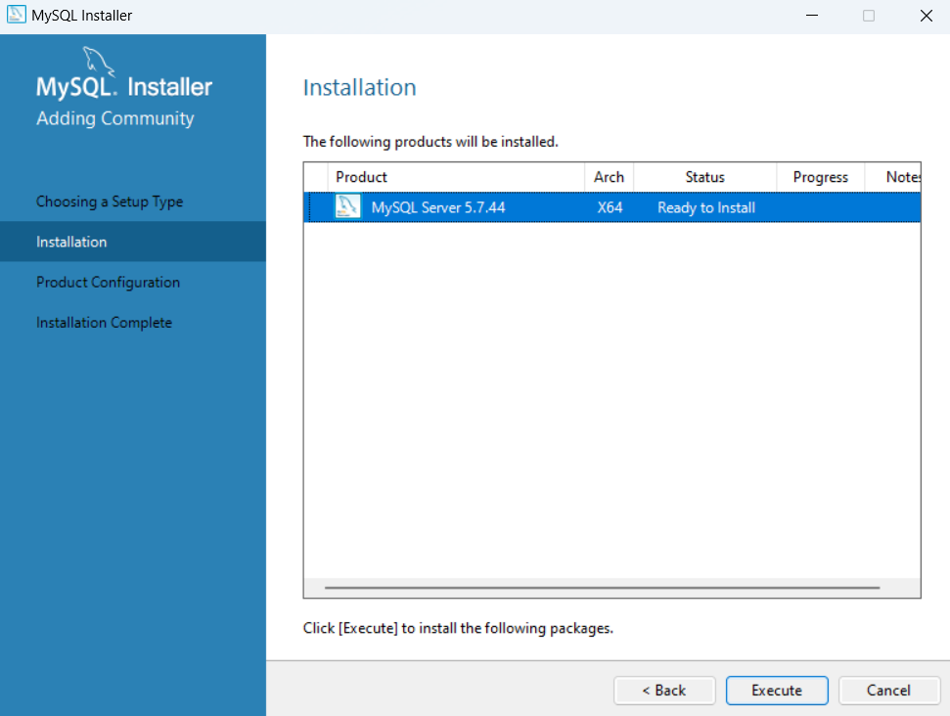

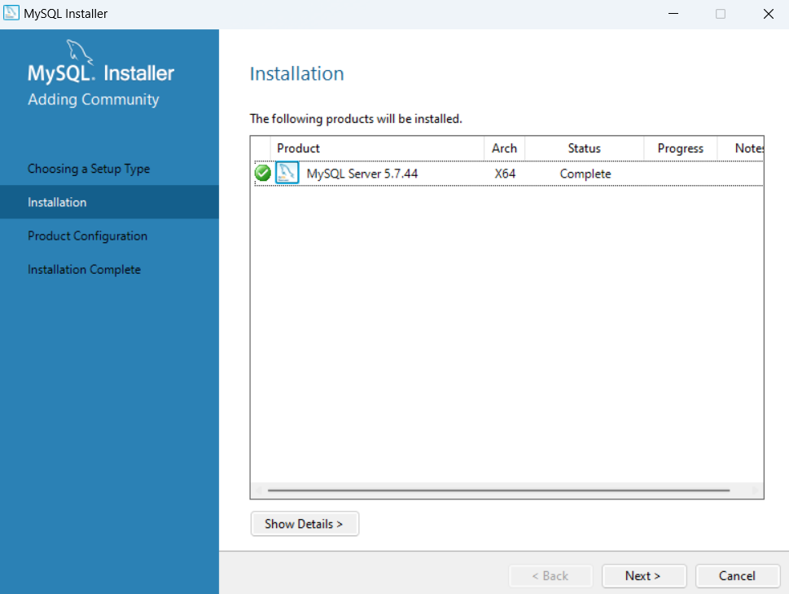

**I started the configuration process**

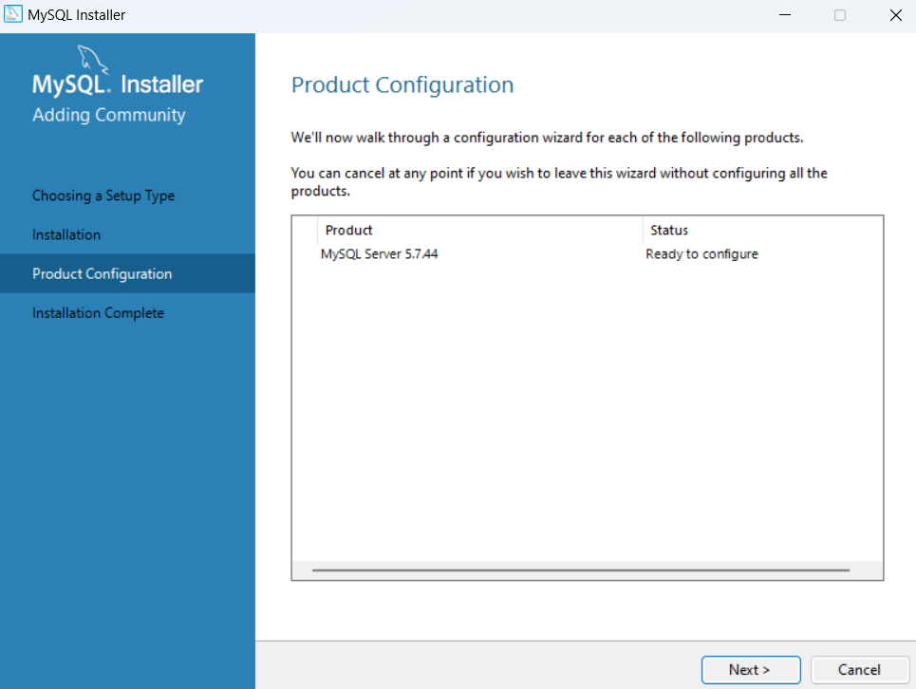

**I kept the typing and networking configurations at default**

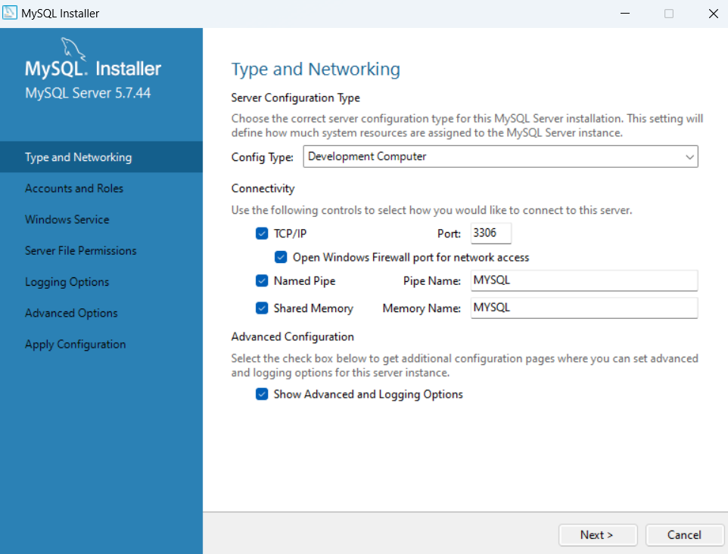

**I kept the named Pipe at default**

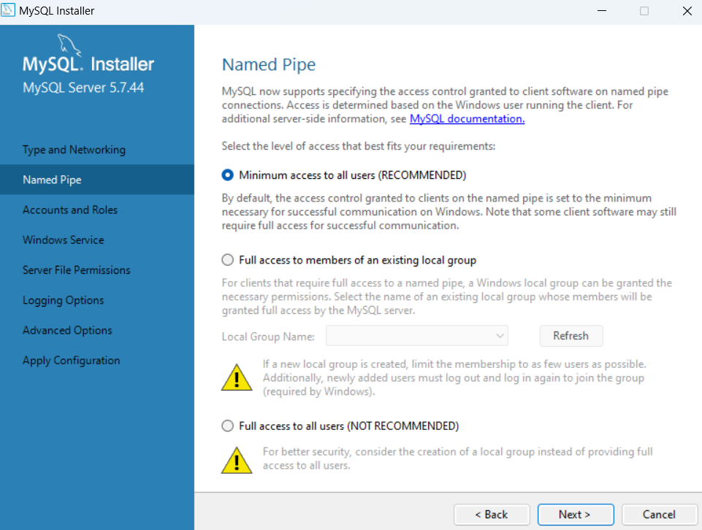

**I set my MySQL root password**

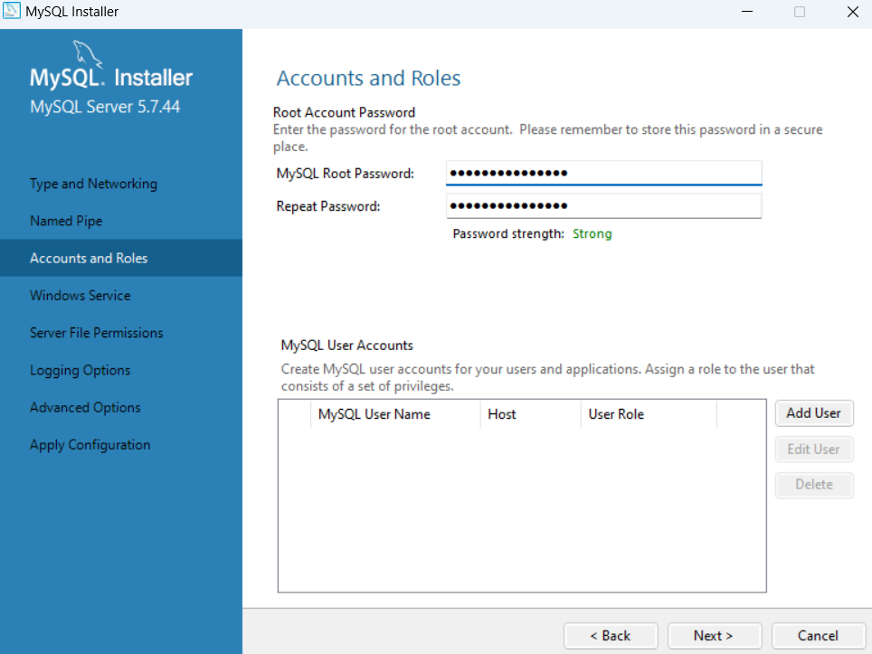

**I left the Windows Service configuration at default**

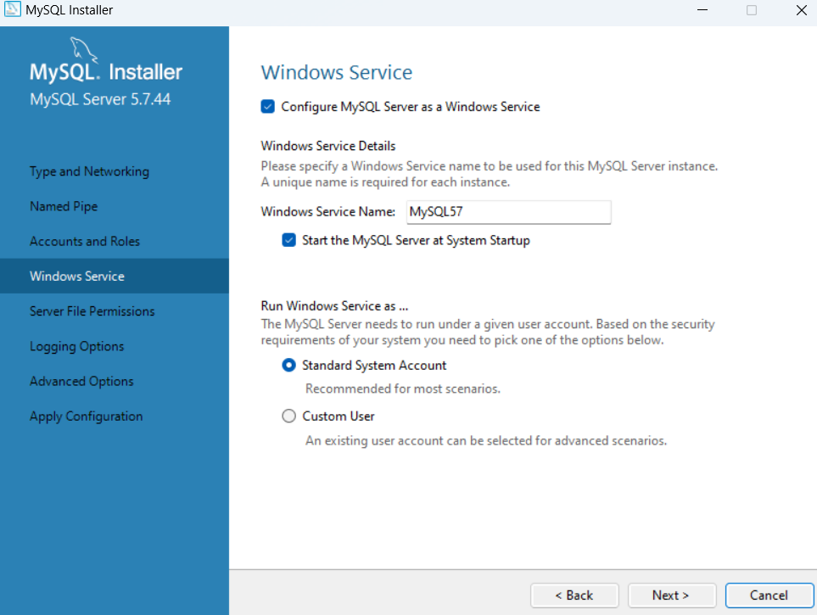

**I left the Server File Permissions configuration at default**

**I left the Logging Options configuration at default**

**I Left the Advanced Options configuration at default**

**I executed the configuration**

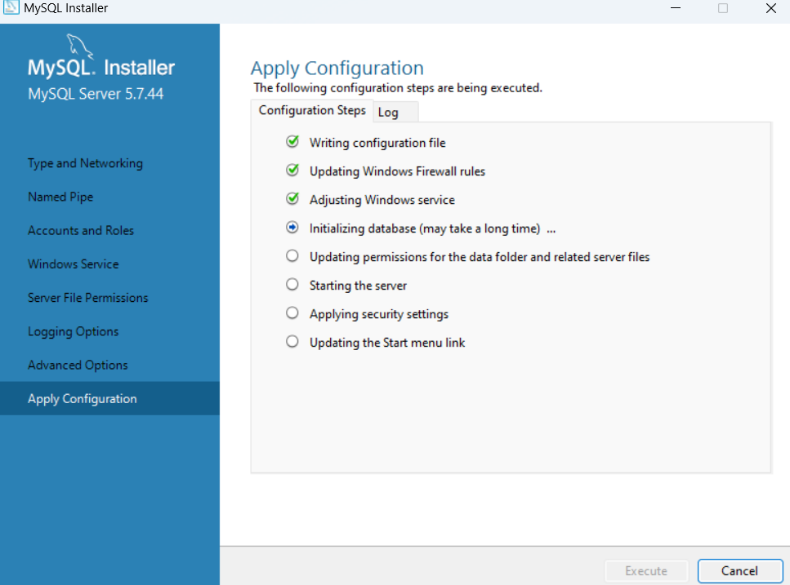

**Conclusion**

My MySQL app was successfully installed

I documented everything, using version 5.7.44.0

Then I came across an error, where the database failed to initialize

**Troubleshooting**

I thought this could be because I had already installed it before

So, I deleted the app, and all the folders related to MySQL i.e., in my c drive directory i.e., ProgramData, ProgramFiles, ProgramFilesx86 and in the Windows folder in the local and roaming subfolder

Once that was done, I downloaded the latest version of MySQL, which is

version 8.0.37

I set it up, (I did not take screenshots of this process, as I had not realized that what I downloaded and what I screenshot were 2 separate versions)

I followed the same steps, and the installation was a success

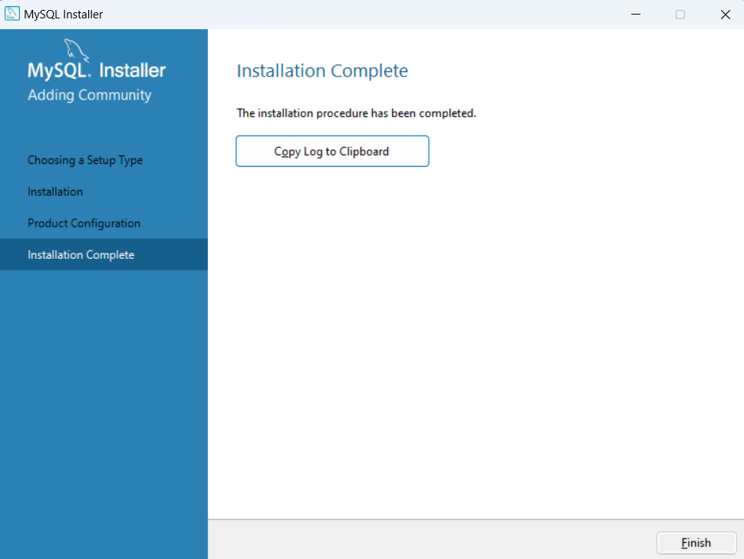

**Installation of MySQL Workbench**

I downloaded MySQL Workbench version 8.0. CE

@<https://dev.mysql.com/downloads/workbench/>

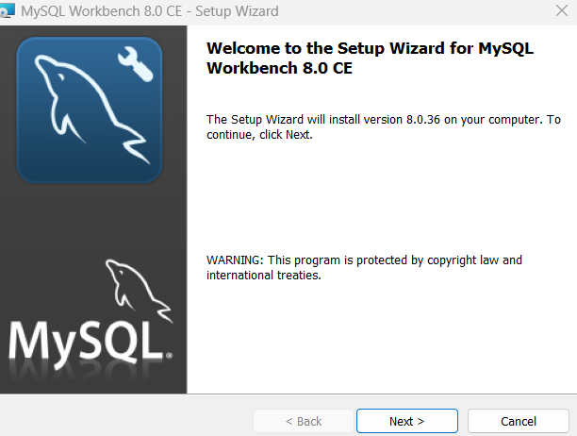

**I left the distination folder as is**

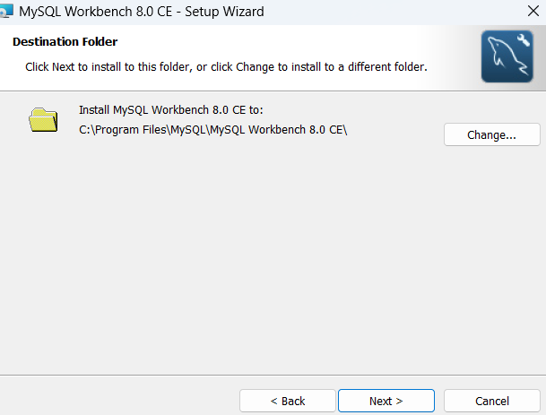

**I left the setup type at default**

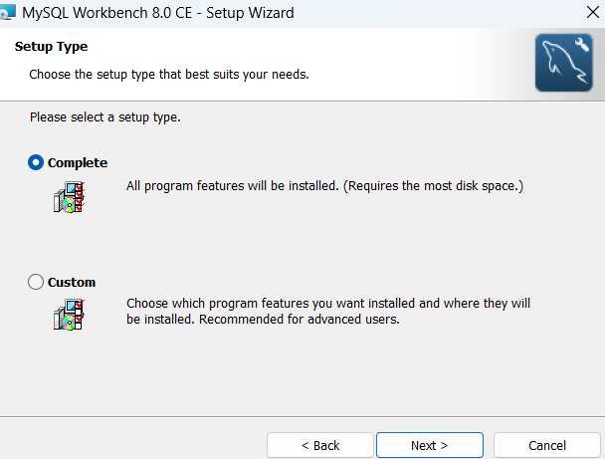

**I selected the install tab**

**I allowed the app to make changes to my device**

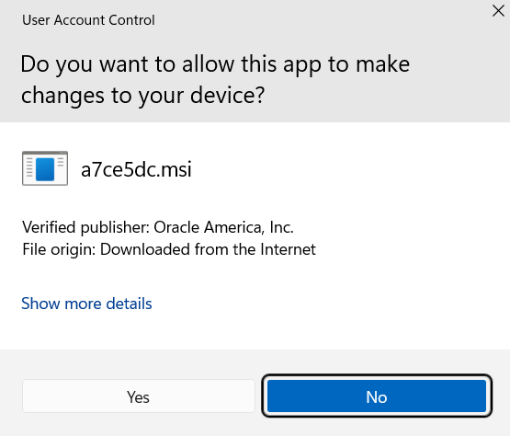

**The installation was a success**

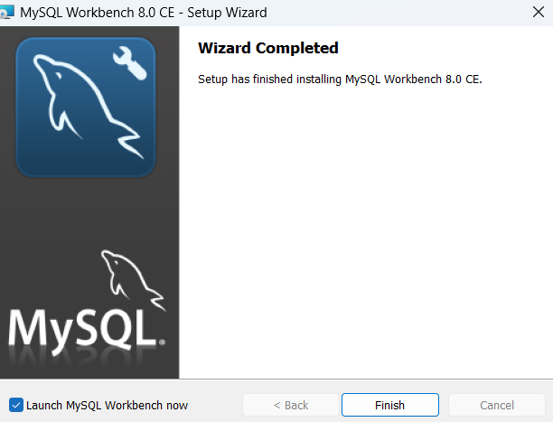

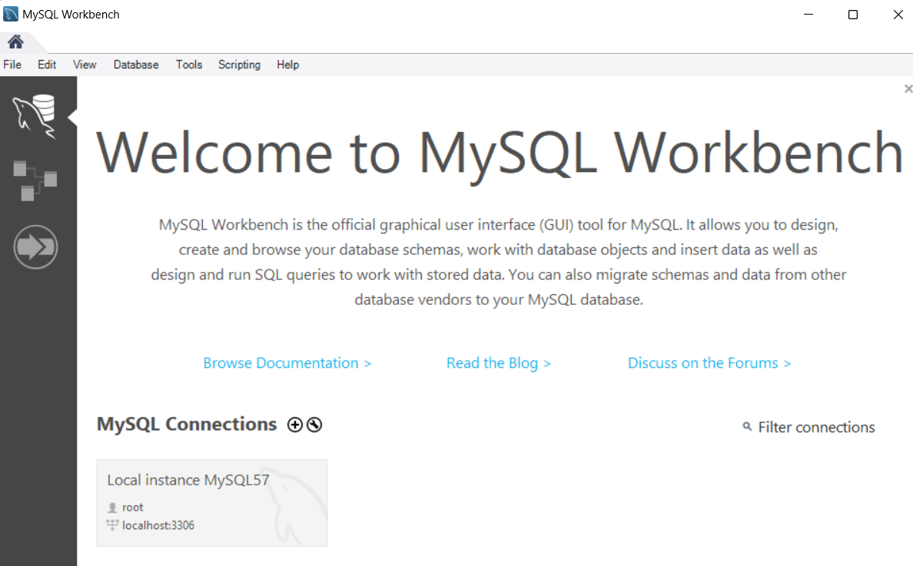

**I entered my password, and the interface opened**

**8. Other extensions, plugins and add-ons**

**For syntax highlighting**

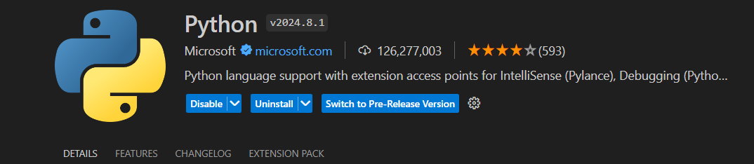

**For linting**



**For code formatting**



**For version control integration**

